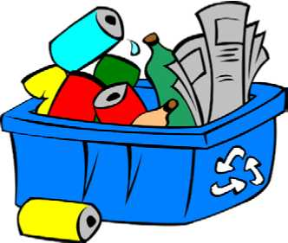
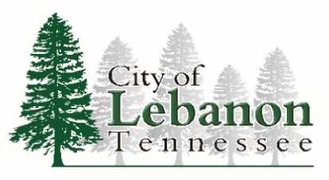

Help us…

...take it to the curb!

(instead of to the landfill)

City of Lebanon - Curbside Recycling Program

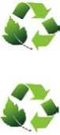
No sorting - all recyclables loose in the cart together

Pick-up at the curb - simply roll cart to the curb every other Monday
Recyclable items that can be included in the cart:
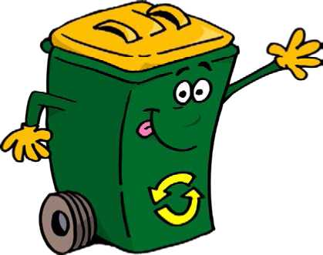
Plastics: plastic bottles and lids, plastic jugs, milk jugs, detergent containers, (Styrofoam is not accepted) No plastic bags or bagged recyclables please.
Metals: aluminum cans, steel cans, tin cans (rinsed)
Paper: newspaper, magazines, junk mail, envelopes
Cardboard: cereal boxes, shoe boxes, etc. (discard/ remove inside plastic liners, bubble wrap, peanuts, etc)
Signing up is simple!
Register online: www.lebanontn.org/recycling
Questions? Please call 615.444.0825 (ext 5103)

